TourneyMan
Scrabble® Tournament Software

1. Introduction
This software is designed to help tournament directors run a Scrabble® tournament by automating processes of pairings and standings. This software has been used since 1992 to help run the National Scrabble® Championships. Hopefully with feedback from the NSA and tournament directors, this software can be honed to be truly useful for all directors.

2. Operation

2.1 Startup

To get past the startup window (Figure 1) one will need to input the password, For now it is JEFE.

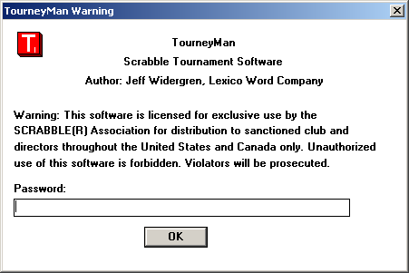
Figure 1. Startup Dialog

2.2 Files, Divisions, and Pairing Groups

The software allows one to put all players in a tournament in one (.ltm) file or put separate pairing groups and/or divisions into separate (.ltm) files. However, a single pairing group cannot be spread across multiple files. Historically at the NSC, we put each division (pairing group) on a separate computer. For smaller tournaments, where only computer is used, putting all players in one file is probably best. If you choose to use separate files for each pairing group (division), you can open multiple copies of TourneyMan and they can be seen simultaneously on your desktop. Separate tournaments such as an early bird followed by a main event should be put into separate files.
To build a new file, select menu item File|New. To access files that you have previously built and saved, select menu item File|Open....

2.2.1 All players in one file
- Advantage: Separate pairing groups (divisions) possible within one file. One file to submit to NSA
- Disadvantage: For now, player numbers are not unique because each file starts player numbers at 1.

2.2.2 Separate file for each pairing group (division)
- Advantage: Less confusing if lower rated players are playing up. Player numbers consecutive within the division
- Disadvantage: Need to set up and open multiple files to enter game scores, multiple files to submit to NSA

2.3 Tournament Setup

Before getting started with player/game entry, it is best to go through the tournament setup (menu: Tourney|Setup) dialog box (Figure 2) to specify important parameters for your tournament.
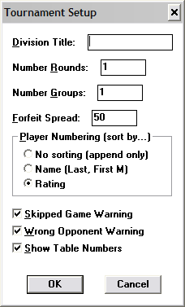
Figure 2. Tournament Setup Dialog

Division Title (will be included on printouts):
- If all players are in a single file, use this box for the name of the tournament (limit 20 characters, no numbers)
- If each division is in a separate file, use this box for the name of the division (limit 20 characters, no numbers). Complete a separate “Tourney Setup” for each division.

Number Rounds:
- Enter the number of rounds for your tournament

Number Groups:
- Enter the number of pairing groups (divisions) for this file. If you are using a separate file for each division, this number should be 1.

Forfeit Spread:
- Default is 50. This allows TourneyMan to automatically add 50 points to the score of a player with BYE opponent.

Player Numbering (sort by …)
- Default is to sort players by rating. TourneyMan will automatically resort each time a new player is entered, or ratings are updated
- Sort by name is an option. Used at NSC, it enables players in a large division to readily find their player numbers.
- No sorting (append only). Select this option if you wish to freeze current player numbers. Additional players will be added at the end of the group. After the tournament is paired, players can be appended.

Warnings:
- Skipped Game Warning: If set, this will warn you if you are entering a game score when a prior game for one of the two players has not been entered.
- Wrong Opponent Warning: If set, this will warn you if you are inputting data for players who were not paired.
- Show Table Numbers: Table numbers will display on pairing printouts. If your tournament does not use table numbers you may disable this.

(Moreover, if you want to split one of your pairing groups into different class prize ranges, you can increase the number of groups to accommodate that) eliminate this info since it does not work

2.4 Player Data Entry

Before pairing and entering game data, one will need to enter data for all players. It is possible after the tournament has started to add players, but this is typically not done. Pull up the Edit Player Dialog box (menu: Tourney|Edit Player or Ctrl-P or hit enter when a player is currently highlighted) (Figure 3) to begin inputting or editing data for a particular player. TourneyMan will issue player numbers in order of rating. For players with the same rating, or nonrated players, numbers will be issued in the order in which the players are entered.
- New Player: Add by inputting name, pairing group and rating. For nonrated players, enter 0. If you are using a separate file for each division, you need to be sure you are using the correct file.
- SP ID: This field is currently not used.
- Active for Pairing: Default setting. If a player drops out and it is desired not to renumber, deactivate that player rather than deleting.
- To edit a player’s information , you may choose the previously entered player from the Player Select dropdown
- You may delete a player before the tournament has been started (pairings are done).

After entering player data, SAVE YOUR FILE (menu File:Save or Ctrl S). This will save your file as a (.ltm) which can be opened only through menu File:Open. Give your file an appropriate name similar to the name you have used in Tournament Setup and put it in a previously selected folder. Save each time you make any changes. Save often to prevent loss of data!

When <New Player> is listed in the player select dropdown, then a new player can be added by inputting name, group, and rating info. By default, new players are selected as active for pairing. If a player drops out and it is desired not to renumber, then instead of deleting the player, simply deactivate that person from pairing.

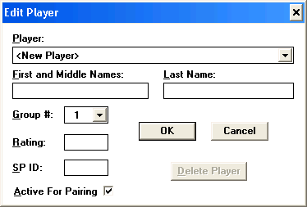
Figure 3. Player Edit Dialog

To edit a player’s info or to deactivate or delete them, simply choose that player from the Player Select Dropdown.

2.5 Views

2.5.1 View Customize

The View Customize Dialog Box, (menu: View|Customize) (Figure 4) can be used to configure what is displayed on the screen, and ultimately what is contained on printouts for player roster, standings and specialty prizes.

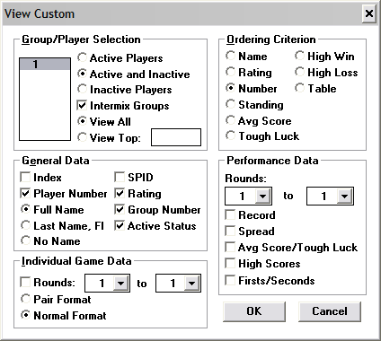
Figure 4. View Custom Dialog
- Group/Player Selection:
Select what you wish to display. You may limit the players on your display by choosing all, active or inactive. If you have multiple pairing groups in your file, you may display the players one or both groups by selecting/deselecting “Intermix Groups”. You can view all, or just the top few (i.e. top 3, useful for abbreviated standings)

- Ordering Criterion:
Select the order in which you wish to view players depending on the desired printout. Name, Rating, Player Number are self-explanatory.
Standing, Average Score, High Win and High Loss are sorted based on the rounds specified in the Performance Data portion of the “View Custom” dialog box. Tough Luck is the sum of lowest losing margins with at least seven losses. Sorting by table for a particular round may be helpful.

- General Data:
Specifies how individual player information is displayed. Index (the order in which players are sorted for the current sorting method. Helpful for standings. Number, Name (full or last name with first initial or no name), SPID, Rating, Group number and Active status. You may select multiple options.
- Performance Data:
Specify the round(s) for which you wish to display data. You may display record, spread, average scores (with tough luck calculation), high scores and the number of firsts and seconds for those rounds.
- Individual Game Data:
Specify the round(s) for which you wish to display data. Select Pair Format to display abbreviated pairings (opp/table#). You can use this selection to see if all the game scores for a particular round have been entered. Select Normal Format to display full information for all games. If you choose to print the Normal Format, you will print a separate page for each player, which is useful for verifying scorecards. If you do not wish to display any pairing information on your printout, deselect the rounds.

2.5.1 View Pairings

The View Pairings Dialog Box, (menu: View|Pairings…) (Figure 5) can be used to very quickly print out pairings that have been made (see other sections on pairing methods).

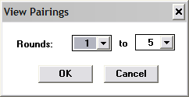
Figure 5 - View Pairings Dialog

2.5.2 View Standings

The View Standings Dialog Box, (menu: View|Standings…) (Figure 6) can be used to very quickly print out standings. As an option, paired rounds can be shown also, but the order of the list will still be by standing.
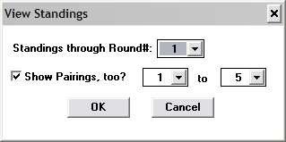
Figure 6 - View Standings Dialog

2.6 Pairing players.

TourneyMan makes pairing easy for almost all situations, by use of ‘Assisted Pairings’. However, TourneyMan allows great power and flexibility for unusual pairing paradigms, such as at the NSC, using ‘Custom Pairings’. Most tournaments will need Assisted Pairings exclusively.

2.6.1 Assisted pairings

Assisted pairings are intended for the ever popular one-day round robin (RR) tournaments, optionally with one final king-of-the-hill (KOTH) round, and for R. Fontes creation, Portland Swiss (PS). Assisted Pairings require that the games will start at table 1, that each group, if there is more than one in the file, represents a separate pairing group, and that rematches will be avoided, if possible, until the final round. If these assumptions are not met, then Custom Pairings must be used (see the next section). Use of Assisted Pairings is best shown with two very common tournament types, RR+KOTH and PS.

2.6.1.1 Pairing Examples

2.6.1.1.1 Round Robin with one KOTH last round

First, one will need to make sure that each round robin group is in a separate ‘group’ number inside the file. The total number of groups is set in the Tourney|Setup… dialog, and each person’s group number can be set in the Tourney|Player Edit… dialog. The topic of groups is discussed earlier in this document. It is okay if one group, usually the last one, is larger than the rest, because it often happens that the total number of players in the tournament is not divisible by the intended round robin size. However, for that last odd-sized group, obviously, no one in that group will play all other players in that group. After the grouping has been done, then the actual pairing is very simple. Let’s show an example for a RR5+KOTH, where each round robin group will have 6 players. Tourney|Assisted Pairings… should be chosen from the menu and filled out as shown in figure 7.

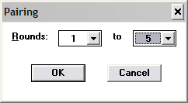
Figure 7 – Assisted Pairings Dialog, Initial Pairing

At this point, you should probably save the file, and then print out the pairings (see the sections on Views and Printing). After all the data for these (5) rounds is entered, you may simply pair the final (KOTH) round using Assisted Pairings again as shown below in figure 8.

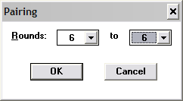
Figure 8 – Assisted Pairings Dialog, KOTH pairing

2.6.1.1.2 Portland Swiss

Running a Portland Swiss (PS) tournament has many similarities to running a round-robin tournament. However, there are differences. The groups for PS are not necessarily even sized like for RR, but usually chosen by rating ranges. The initial pairing for PS usually cover the first 3 or 5 rounds as shown for the 5 round case in figure 7.
So, essentially, the initial pairing for RR and PS are the same. PS at this point is done a little differently from this point forward. The advantage of PS is that pairings are made for a round, say round 6, after round 4 data has been completely entered into the program, and while round 5 is being played and no results from round 5 have been entered. In this way, for example, round 6 pairings can be posted and ready for players as they finish round 5. So the general rule is to pair round N, while round N-1 is being played. The only exception is when there is a break between rounds N-1 and N, such that all the data for round N-1 can be entered before pairing round N without causing a delay. In PS, each round is paired one at a time, so as in Figure 8, the Rounds: 6 to 6 indicate that only one round, round 6 is being paired. Even after a break when there are two rounds to pair before play begins, pair them one round at a time, using two invocations of the Assisted Pairings dialog. For the rest of the tournament, simply continue to use the Assisted Pairing dialog, pairing one round at a time. That’s it. The software will automatically have a KOTH round in the final round, and will eliminate rematches up until that point, assuming that there are more players than rounds.
Once again, for PS, as for RR, it is assumed for Assisted Pairings that all groups in a file represent separate pairings groups (or there is only one group per file). However, if the number of players in a group is less than or only slightly more than the number of rounds, then you will probably want to pair a full round robin among all the players in that group. If you have a file that has some groups that need to be paired initially with 3 or 5 rounds, while other need a larger amount, then you will need to use custom pairings and do them separately, OR put the groups in separate files and use Assisted Pairings.

2.6.2 Customized pairings

The Custom Pairing Dialog Box, (menu: Tourney|Custom Pairing …) (Figure 9) can be used to configure player pairing.

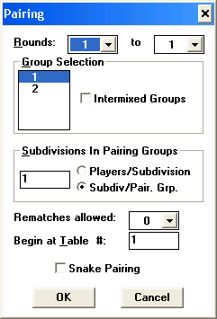
Figure 9. Custom Pairing Dialog
Custom Pairing:
- Choose the range of rounds which are to be paired.
- Select which groups are to be paired, and whether they should be paired separately or together.
If the file contains one pairing group, select the groups and “Intermixed Groups”.
If the file contains multiple groups which are all separate pairing groups, select all the groups and do NOT select “Intermixed Groups”.
- Select the Subdivisions in Pairing Groups (several examples will follow). You will either designate the number of players per subdivision or number of subdivisions per pairing group.
- Select the number of rematches you wish to allow through the number of rounds currently being paired.
- Select the starting table for the current pairing group(s). This will be automatically incremented based on the number of players being paired.
- Indicate whether Snake Pairings will be used. As an example of snake pairings, if there were 8 players being paired for three rounds then one round robin group would be 1, 4, 5, and 8, and the other 2, 3, 6, and 7. Normally, the groups would have been 1, 3, 5, and 7 and 2, 4, 6, and 8. Snake is ideally supposed to be a more fair pairing system. Note: when doing King-of-the-hill (KOTH) one round pairings do not set for snake pairing.

If the file contains several groups per pairing group and several pairing groups, then you will need to select all the groups that comprise ONE pairing group and select intermixed groups, and repeat that process for each pairing group in the file.

2.7 Entering Game Data

The Edit Game Dialog Box, (menu: Tourney|Edit Game… or Ctrl-G or hitting return when a game is currently highlighted) (Figure 10) can be used to enter or edit game data.
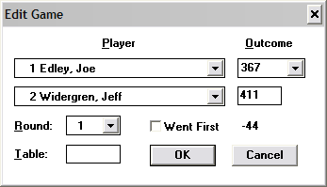
Figure 10 - Edit Game Dialog

Initially the focus is on the first player, and simply typing the last name or entering the player number will pull up the game data or pairing for that player. By default, after a pairing, the outcome will show PAIR for each player and the table number where they are paired. (If you have chosen not to use TourneyMan for your pairings, you may enter the opponent’s player number as well). After selecting the first player, a different round can be chosen to get to different game data for a player.
For a player with a bye round, “No Player” will display as the opponent. Player outcome should be entered as FWIN (Forfeit Win) from the pull down menu. The Bye will default to FLOS (Forfeit Loss) and 50 points will be added to the winning player’s cumulative score.

2.8 Printing the Current View

The View Print Dialog Box, (menu: View|Print) can be used to print the current view.

2.9 Saving the Current View to a File

Because TourneyMan has used the default fixed printer font (pretty small), we have added an option to print the view to a file. You can access this feature through File|Save View. Then it can be opened in MSWord or other word processor, and reformatted before being printed.
This procedure will go faster if you create a style (monospaced font so the columns will line up properly, font size, bold if you want it) such as Monospace821 BT, 12 point, bold.
In Microsoft Works, create your style sheet in the Format/Format Gallery. In Microsoft Word, create your style sheet in Format/Styles and Formatting. In other word processors, check your help file to learn how to create a style if you don't already know how to do it.
Then you can leave the word processing program open during the tournament, easily open the TourneyMan .txt files, highlight the text, click on the style in the style list, and then print.

2.10 Saving the File for the NSA

You can save the game data in the NSA sanctioned format by doing selecting File|Save for Joe. At the point when the NSA is ready for score data, then the File|Save for Chew, menu item will be important.

